|  |
| --- |
| RLE COMPression  Phone List compression |

# members

|  |
| --- |
| 1-Viola Tarek Zaher sec2  2-Kathrine Wassef Salama sec2 |
|  |

# introduction

|  |
| --- |
| This is a report of data compression as we compress phone list as text file and decompressed it  Using C++ language . |
|  |

# Algorithm

|  |
| --- |
| We have used RLE on char level to compress this text file ( PhoneList.txt) |

# FlowChart

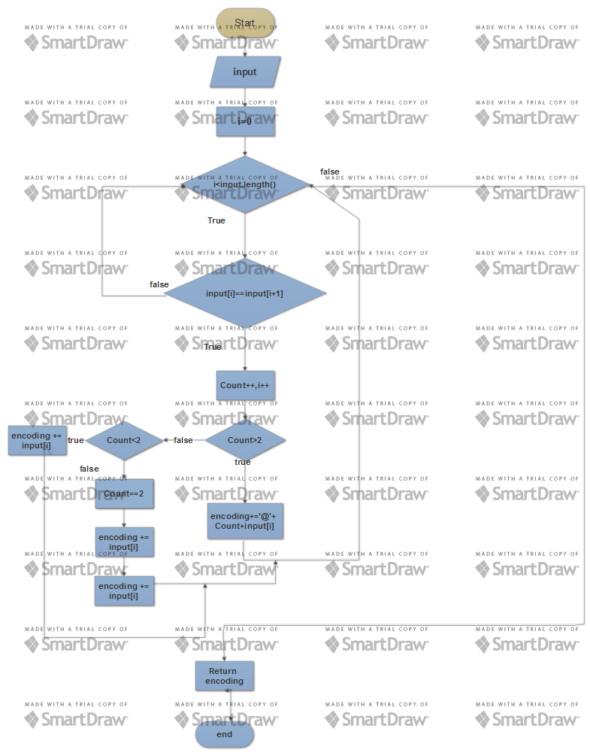

# Output sample:

The compressed file:

AliLoay 20405092839717 AtaiaBasme 3@313051084433

The decompressed file:

Ali Loay

20405092839717

Ataia Basme

31113051084433

# conclusion

the original file is stored in 763 bytes , but the compressed file will be stored in 632 bytes. Compression ratio= 632/763 = 0.828=82.8% So this type of compression is suitable for this data.